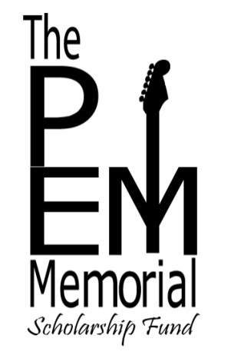

Preston. Eckerle. Morrison. Memorial Scholarship (P.E.M. MS)
The Preston. Eckerle. Morrison. Memorial Scholarship (P.E.M. MS) is designed to financially assist qualified students in obtaining degrees from accredited academic institutions of higher learning in the field of the Arts or Music with any relation to these disciplines. The scholarship is open to any Finneytown High School (FHS) senior whom is preparing to enter an accredited degree-granting college or university and pursuing an undergraduate degree. The goal is to award three one-time awards each year; the amounts will be determined by the sum of the annual collection through fundraising and gift giving.
The scholarships are awarded based on merit as measured by academic performance and extracurricular activities.
Application Guidelines
- Scholarships are limited to use at an accredited degree granting institution of higher learning in the field of Arts or Music with any relation to these disciplines.
- Scholarships are open to any student entering an accredited degree granting institution. Evidence of enrollment is required.
- Full-time and part-time studies are both eligible for consideration.
- Students will provide the following to the Selection Committee: a completed application, copy of official FHS transcript, resume, essay, and reference letters.
- Application deadline is the 1st of April each year; award recipients will be notified in May prior to the awards ceremony.
- Scholarships are paid directly to the College institution based on acknowledgement that monies have been spent towards the qualifying education costs.
- All scholarships are subject to annual funds availability through direct donations or through actual and/or accrued interest earning from endowments.
- Scholarships will be awarded without regard to race, color, gender, religion, national origin, age, sexual orientation, or disability.
Application Packet
The application packet will include the following:
- Completed application form.
- One page essay describing why the student wants to pursue a degree of higher learning in the field of Arts or Music.
- One copy of the latest available official FHS transcript.
- Resume outlining educational background, work experience, co-curricular and extracurricular activities.
- Two letters of reference (who are not relatives of the student) that address the suitability of the student for the award, the nature of the relationship with the student, and the length of time of the relationship.

All materials submitted for consideration for a scholarship automatically become the physical property of the P.E.M. MS and will not be returned to the student. They will not be used by the scholarship committee for any purpose except to help determine who receives a scholarship for any given academic year.

All application materials should be sent to:
P.E.M. MS C/O John Hutchins
10038 Winlake Drive
Cincinnati, OH 45231

Candidate Evaluation and Selection
The P.E.M. MS Selection Committee, an impartial panel of no less than three and no more than seven appropriately qualified and training scholarship judges comprised of project management practitioners, academics, and others.
All decisions of the P.E.M. MS and its Scholarship Evaluation and Selection Committee are final.
Preference will be given to candidates with the best combination of academic, co-curricular and extracurricular performance, with highest potential for success.

Notification and Award
Scholarship recipient(s) will be notified in early May prior to the FHS Senior Awards night.
Scholarships will be awarded at the FHS Senior Awards night in May.
Descriptions of all scholarships will be published on the Finneytown Schools Education Foundation Website.
The name(s) of the scholarship recipient(s) will be published on the Finneytown Schools Education Foundation Website, and in P.E.M. MS publications as appropriate.
Preserving 3 Memories ~ Building 3 Dreams
www.pemmemorial.org

